


Project Id: 2026-27CSEMPID017
Project Synopsis
on
ELECTICORE : An AI-Enabled Smart Student Management Portal for Elections (Voting), and Academic Collaboration
Submitted in Partial Fulfilment of the Requirement
For the Degree of
Bachelor of Technology
In
Computer Science and Engineering
By
Dhruv Sharma (2502900100093)
Dhruv Pratap Singh (2502900100092)
Dharmendra Kumar Sharma (2502900100090)
Jitendra Kumar Sharma (2502900100112)

Under the Supervision of
MRS. Monika Gaur
Faculty Guide / Department Supervisor
Department of Computer Science and Engineering

ABES INSTITUTE OF TECHNOLOGY, GHAZIABAD

AFFILIATED TO
Dr. A.P.J. ABDUL KALAM TECHNICAL UNIVERSITY, UTTAR PRADESH, LUCKNOW
(ODD SEM, 2026-27)
Table of Contents

Chapter No. | Contents | Page No.
1 | Abstract | 3
2 | Introduction | 4
3 | Literature Survey | 5
4 | Problem Statement | 6
5 | Proposed Methodology | 7
6 | Conclusion and Future Scope | 10
7 | References | 11
Abstract
College campuses continue to rely on fragmented, manual processes for student elections, ragging redressal, faculty communication, and information sharing, which reduces transparency, delays action, and leaves students disconnected from timely opportunities. Electicore addresses this gap by proposing a single, AI-enabled web platform that unifies these services. The system provides a secure, one-student-one-vote online election module for electing Class Representatives and Student Council members; an AI-assisted Anti-Ragging Report Centre where a submitted complaint is analysed by an AI model, converted into a formal email, and automatically routed to the concerned faculty or Anti-Ragging Committee; a centralised Faculty Directory; and a Notes and Events Hub for sharing study material and campus announcements. The platform is built using a Flask-based Python backend, an HTML5/Tailwind CSS frontend, an SQLite database, the OpenAI API for natural-language processing, and Gmail SMTP for automated email delivery. The proposed design is expected to make campus elections more transparent, shorten the response time for ragging complaints, simplify faculty–student communication, and reduce the fragmentation of academic resources, resulting in a smarter, safer, and better-connected campus community.
Keywords: Smart Campus Management, Online Voting System, Artificial Intelligence, Anti-Ragging Portal, Student Services, Flask, Natural Language Processing
Introduction
Higher-education institutions today manage a wide range of day-to-day student services — conducting Class Representative and Student Council elections, handling sensitive complaints such as ragging incidents, connecting students with faculty for academic guidance, circulating study notes, and publicising events, hackathons and workshops. In most colleges, including many affiliated to Dr. A.P.J. Abdul Kalam Technical University, these functions are still handled through disconnected, largely manual channels: elections are conducted on paper or through informal show-of-hands processes, ragging complaints are reported verbally or through slow administrative escalation, faculty contact details are scattered across notice boards or departmental pages, and notes and event information circulate informally through WhatsApp groups or personal contacts. This fragmentation reduces transparency, delays redressal, and causes students to miss important academic and extracurricular opportunities.
ELECTICORE is proposed as an AI-enabled web platform that consolidates these services into a single, secure, and user-friendly system. The most distinctive component of the platform is its AI-assisted Anti-Ragging Report Centre: instead of requiring a student to draft a complaint and identify the right authority to escalate it to, the system allows the student to confidentially describe the incident, after which an AI model analyses the complaint, drafts a professional email, and automatically sends it to the concerned faculty member or the institution's Anti-Ragging Committee. This significantly reduces the time and effort a distressed student has to spend navigating the reporting process, while preserving confidentiality.
The platform's second core component is a secure digital election module that enforces a strict one-student-one-vote policy through authenticated logins, and produces transparent, tamper-resistant results for CR and Student Council elections — replacing manual ballot counting with a verifiable digital process.
In addition to these two primary modules, ELECTICORE offers a centralised Faculty Directory that lists department, subject and contact information for every faculty member, making it easier for students to identify whom to approach for academic guidance; and a Notes & Events Hub that lets students upload and access subject-wise study notes and stay informed about hackathons, workshops, seminars, club activities and other campus events, replacing today's scattered and informal channels.
The platform is designed as a lightweight, easily deployable web application using a Python Flask backend, an HTML5/Tailwind CSS frontend, an SQLite database for structured storage, the OpenAI API for the AI-assisted complaint drafting, and Gmail SMTP for automated email delivery. This technology stack keeps the system affordable to build and maintain, which is important given that it is intended for a single institution's internal use and is expected to be extended and scaled in future iterations.
The remainder of this synopsis is organised as follows: Chapter 3 reviews relevant literature in the areas of electronic voting, artificial intelligence and web technologies that inform the design of ELECTICORE; Chapter 4 formally states the problem being addressed and the project objectives; Chapter 5 describes the proposed methodology, technology stack and system architecture; Chapter 6 presents the conclusion and future scope; and Chapter 7 lists the references consulted.
Literature Survey
A review of five recent academic works underpinning the design of ELECTICORE ,Covering secure electronic voting, applied artificial intelligence, web/network architecture, intelligent agents, and collaborative web platforms:
S. No. | Author(s) & Year | Title / Focus Area | Objective | Methodology / Approach | Key Findings
1 | David Chaum (2022) | Secure Electronic Voting Systems | To design online voting mechanisms that preserve voter privacy and result integrity | Cryptographic voter-verifiable receipt schemes for electronic ballots | Secure online voting enhances election transparency, voter privacy, and public trust
2 | Andrew Ng (2024) | Applied Artificial Intelligence | To apply AI/NLP models for automating text-based administrative tasks | Supervised learning and large language models for text analysis and generation | AI improves automation by analysing text, generating emails, and assisting decision-making
3 | Andrew S. Tanenbaum (2023) | Web & Network Systems | To design secure and reliable architectures for web-based systems | Layered client–server network architecture and protocol analysis | Secure, reliable web architectures improve communication and data management
4 | Michael Wooldridge (2023) | Intelligent Agents & Automation | To study how autonomous agents can automate repetitive administrative workflows | Multi-agent system design and rule/AI-based task delegation | AI agents help automate repetitive administrative tasks efficiently
5 | Tim Berners-Lee (2022) | Modern Web Platforms | To evaluate how web platforms can foster collaboration and information sharing | Analysis of web architecture and hypermedia-based information systems | Modern web platforms encourage collaboration, accessibility, and effective information sharing

The reviewed works collectively establish that (a) cryptographically secure, verifiable digital voting is achievable and improves trust over manual elections; (b) AI/NLP techniques can reliably automate text-based administrative work such as complaint drafting; (c) layered, well-architected web systems are essential for secure and reliable multi-module platforms; and (d) agent-based automation and accessible web design both support the kind of unified, always-available service that UNIFORCE aims to provide.
Problem Statement
Description of the Problem
Most colleges — including many AKTU-affiliated institutions — still depend on separate, largely manual systems for core student services. Class Representative and Student Council elections are conducted without digital transparency, making results difficult to verify. Ragging incidents often go unreported or are reported late because students lack a confidential, quick digital channel to escalate complaints. Students frequently struggle to identify the appropriate faculty member for academic guidance due to the absence of a centralised directory. Study notes are shared informally across multiple, disconnected platforms, causing confusion and duplicated effort. Finally, students often miss out on hackathons, workshops, seminars, and other campus events because there is no single, reliable channel for such announcements. Collectively, this fragmentation reduces transparency, delays timely action, and weakens student participation in campus life.
Objectives
- Secure Digital Voting: Design and develop a secure digital voting system for Class Representative and Student Council elections that enforces a strict one-student-one-vote mechanism and produces transparent, verifiable results.
- AI-Assisted Anti-Ragging Portal: Build an AI-assisted Anti-Ragging Report Centre that allows confidential complaint submission and automatically drafts and sends a professional complaint email to the concerned faculty or Anti-Ragging Committee.
- Faculty Directory: Provide a centralised, searchable Faculty Directory to simplify academic guidance and student–faculty communication.
- Notes & Events Hub: Enable students to upload and access subject-wise study notes, and notify them about hackathons, clubs, workshops, seminars, and other college events through a unified hub.
Proposed Methodology
ELECTICORE (integrates four core student-service modules into a single smart web application, built on a common Flask backend and Tailwind CSS frontend:
- Online Election Module: Secure authentication (one login per student), one-student-one-vote enforcement, candidate listing, live/locked voting window, and transparent, auditable result computation for CR and Student Council elections.
- AI Anti-Ragging Module: Confidential complaint submission → AI analyses the complaint and drafts a formal email → email is auto-sent to the concerned faculty/Anti-Ragging Committee → faculty takes action and the status is logged, enabling faster redressal.
- Faculty Directory: Faculty profiles including department, subjects taught, and email/contact details, searchable by students for academic guidance.
- Notes & Events Hub: Upload/download of subject-wise notes, plus categorised announcements for hackathons, clubs, workshops and college events.
Technology Stack
Component | Technology
Frontend | HTML5, CSS3, Tailwind CSS
Backend | Python (Flask)
Database | SQLite
AI Integration | OpenAI API
Email Service | Gmail SMTP
System Architecture (Block Diagram)
The figure below shows the layered architecture: students and faculty interact through the Tailwind CSS frontend, which communicates with the Flask backend over REST APIs. The backend routes requests to the four functional modules, which in turn rely on the SQLite database, the OpenAI API for AI-assisted analysis, Gmail SMTP for automated email delivery, and a common authentication/session layer.
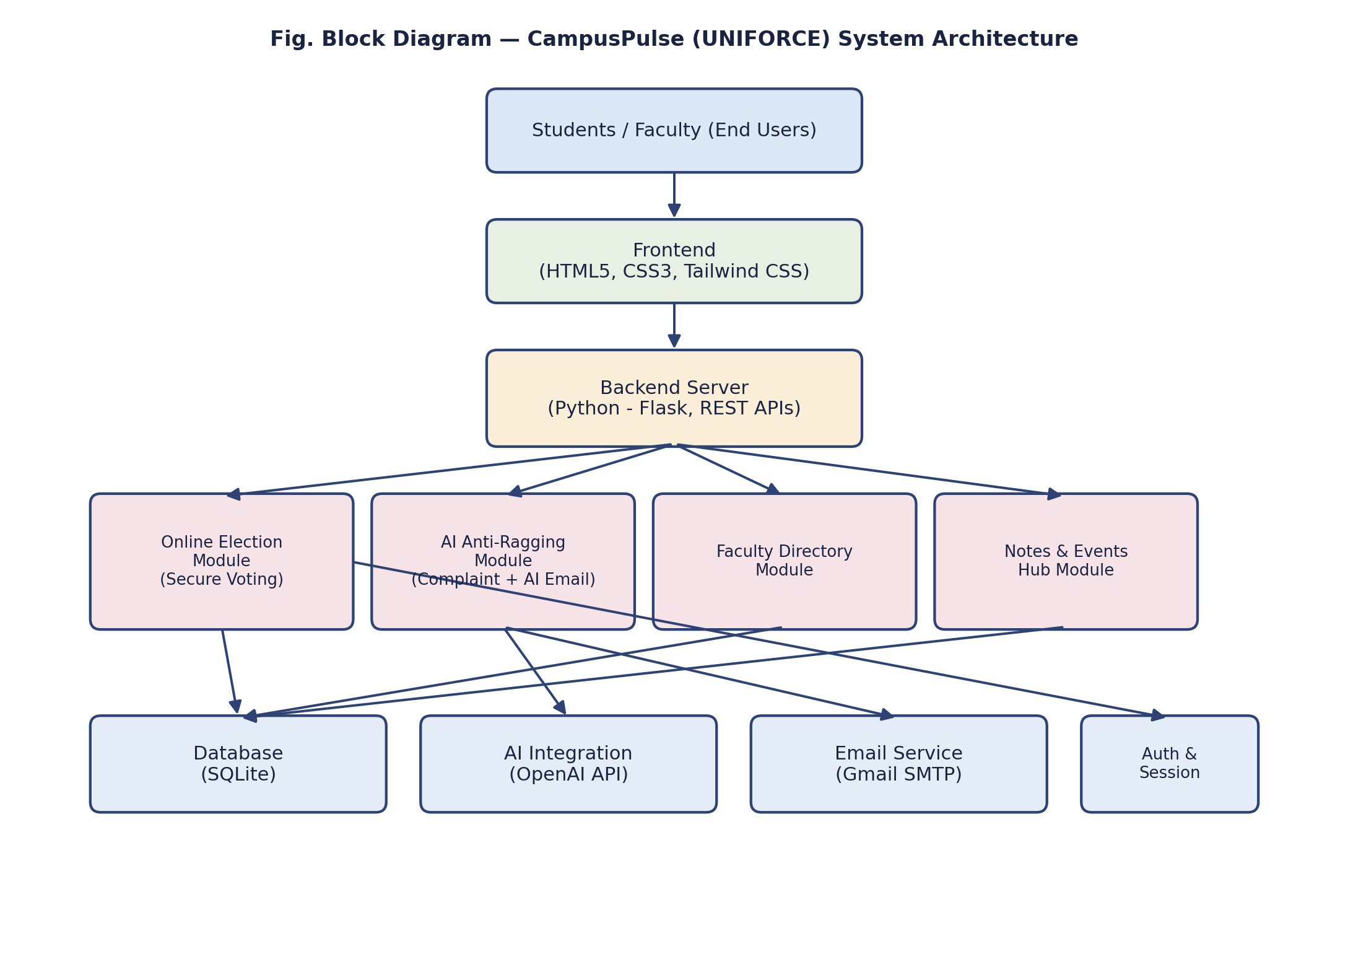
Process Flow — AI Anti-Ragging Module
The flow chart below illustrates the step-by-step process followed when a student files a complaint through the AI Anti-Ragging Report Centre, from confidential submission through AI-assisted drafting to faculty action and status logging.
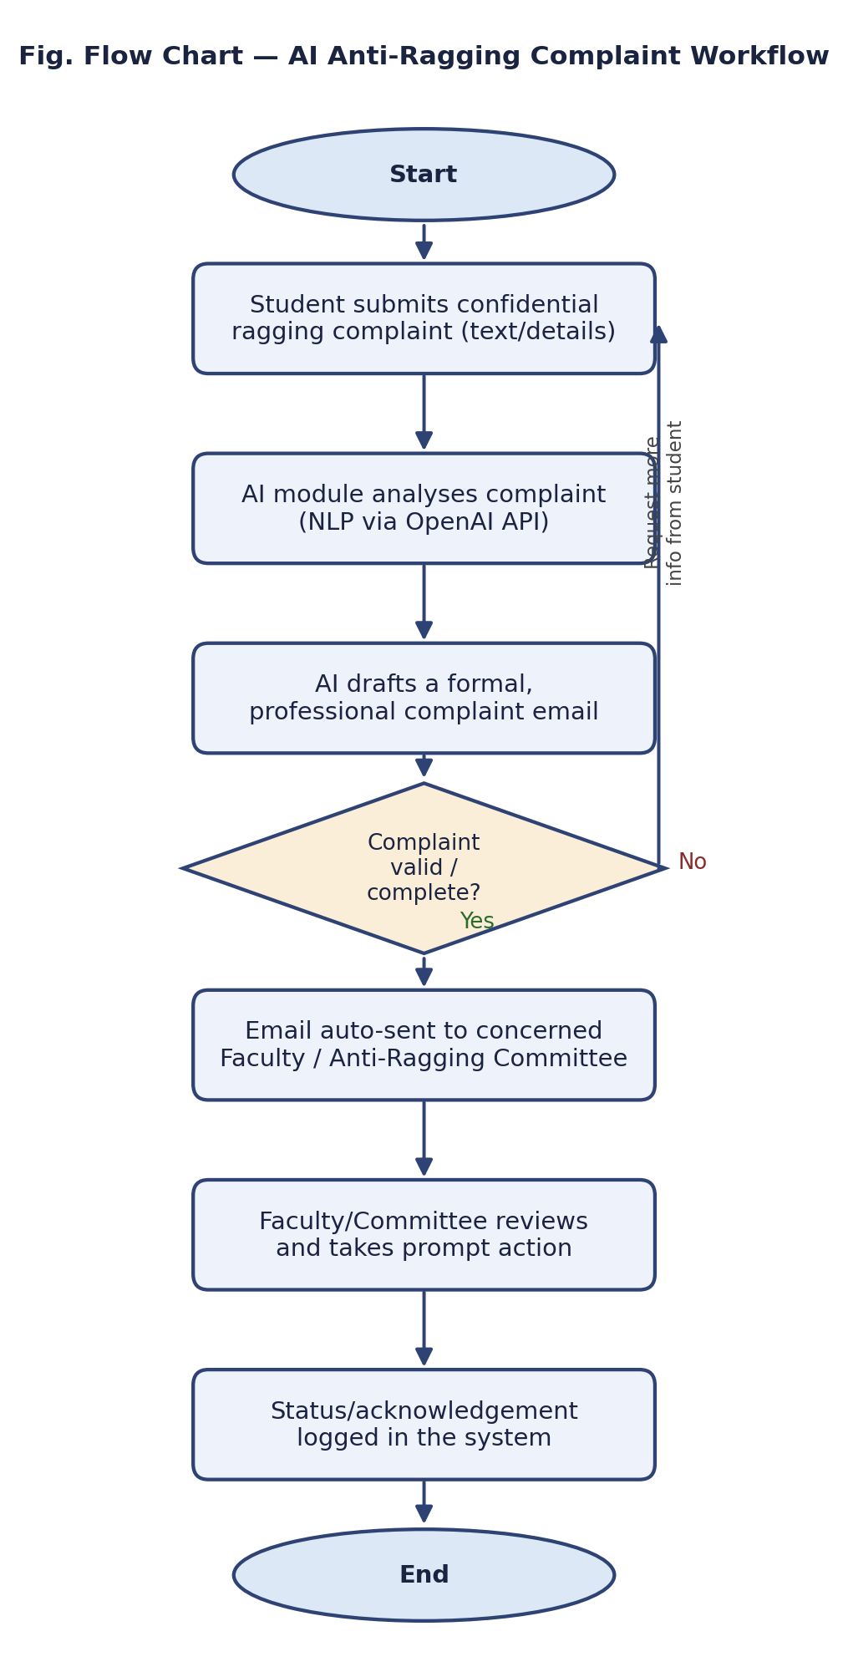
Conclusion and Future Scope
ELECTICORE proposes a unified, AI-enabled platform that brings together secure digital elections, AI-assisted anti-ragging reporting, a centralised faculty directory, and a notes-and-events hub, addressing the transparency, response-time, and communication gaps that arise from today's fragmented, manual campus processes. By combining a lightweight Flask/SQLite backend with an OpenAI-powered natural-language module, the system is designed to be both affordable to build for a single institution and meaningfully faster and more transparent than the manual processes it replaces — particularly for time-sensitive concerns such as ragging complaints.
In future iterations, the platform can be extended with blockchain-backed vote storage for additional election tamper-resistance, a mobile application for wider accessibility, multilingual AI complaint analysis, push notifications for events and results, analytics dashboards for administrators, and integration with the institution's existing ERP/attendance systems so that student verification and faculty data remain automatically synchronised.
References (In APA Format)
[1] Chaum, D. (2004). Secret-ballot receipts: True voter-verifiable elections. IEEE Security & Privacy, 2(1), 38–47.
[2] Ng, A. (2023). Machine learning and deep learning specialization course notes. DeepLearning.AI / Stanford University.
[3] Tanenbaum, A. S., & Wetherall, D. J. (2021). Computer networks (6th ed.). Pearson Education.
[4] Wooldridge, M. (2020). An introduction to multiagent systems (2nd ed.). John Wiley & Sons.
[5] Berners-Lee, T., & Fischetti, M. (2000). Weaving the web: The original design and ultimate destiny of the World Wide Web. HarperBusiness.
[6] Pallets Projects. (2024). Flask documentation. https://flask.palletsprojects.com
[7] Tailwind Labs. (2024). Tailwind CSS documentation. https://tailwindcss.com/docs
[8] OpenAI. (2024). OpenAI API documentation. https://platform.openai.com/docs
[9] Python Software Foundation. (2024). Python language reference. https://docs.python.org

